**EECS 660 Homework 3 Instructions**

The goal of this homework is to implement the Kruskal’s algorithm in the *Algorithm Design* book. The pseudo code is as follows:

***Kruskal’s Algorithm***

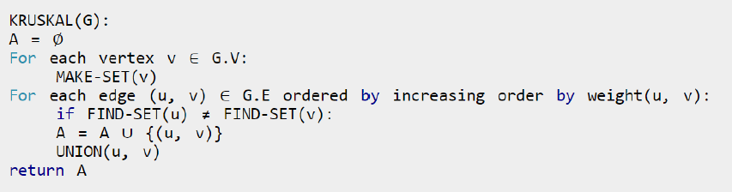

1. Create a python file named “msp_username#”, with ***username#*** corresponding to your ***KU online username with your initials***. For example, if my online username is c935h465, I would create a python file named “msp_c935h465”.

2. Your program should be able to run from the console using the command:

python3 msp_ username#.py input.txt

where the arguments are your program and the input file. ***Your program should write to stdout, not an output file.*** I will be using ***Python 3*** to grade your assignments.

3. Your program should read in an input text file that contains a matrix of the cost of the edges between two given nodes:

0 4 4 0 0

4 0 5 0 0

4 5 0 0 1

0 0 0 0 4

0 0 1 4 0

For example, in this graph, there are 5 nods. The cost of adding an edge from node 0 to node 1 is 4. The cost of adding an edge from node 2 to node 4 is 1.

*Note: edges with cost of 0 are not valid edges to be include in the graph, and should not be considered for the algorithm. Also, there are undirected graph, so cost(i, j) = cost(j, i)*

4. The program should take in the costs of the edges between nodes and performs one of the minimum spanning tree algorithms listed above on the nodes. The program should output the edges in the order that they are include in the graph. For the edge cost matrix above, the **msp** program would output the following:

2 4

0 1

0 2

3 4

*Note: output represents the edge that should be added into tree when running Kruskal’s algorithm. The number of first node should be smaller than the second node in each output eage. For example 2 < 4, 0 < 1, 0 <2, 3 < 4.*

5. You can further test your program by creating input text files following the format of the sample input text files provided.

6. Do not use Numpy package in your program. The original Python can deal with this assignment.

7. Please submit your homework file(.py file) on Blackboard.

8. If you have any questions, please feel free to email me at seanhung0621@ku.edu or [j086l791@ku.edu](mailto:j086l791@ku.edu). BTW, wChiehen will be the grader of this assignment whose email is [seanhung0621@ku.edu](mailto:seanhung0621@ku.edu). We will try to get back to you as quickly as possible.